Mi Band Reminder

Use Case Diagram

Submitted to:

Prof. Ma. Rowena C. Solamo

Faculty Member

Department of Computer Science

College of Engineering

University of the Philippines, Diliman

Submitted by:

Aboy, Blaine Corwyn

Flores, Rafael Luis

In partial fulfillment of Academic Requirements

for the course

CS 191 Software Engineering I

of the

1st Semester, AY 2016-2017

Unique Reference:

The documents are stored in the https://github.com/UPDNSE/Mi-Band-Reminder.

https://github.com/UPDNSE/Mi-Band-Reminder/tree/master/02-Requirements-Engineering.

Document Purpose:

This document gives its readers information regarding the Use Case Diagram. The Use Case Diagram is further detailed with the descriptions of Lists of Actors and Use-cases.

Target Audience:

This document is to be used mainly by the developers as a reference and any reviewers.

Revision Control

*History Revision:*

| Revision Date | Person Responsible | Version  Number | Modification |
| --- | --- | --- | --- |
| 09/21/16 | Aboy, Blaine Corwyn D. | 0.1 | Initial Document; not to be passed yet. Input Unique Reference, Document Purpose, Target Audience. |
|  |  |  |  |

*System Name*: [Name of the System eg. Athlete Record Maintenance System]

*Description*: [Brief Description of the System in 3-7 sentences.]

*Use-Case Diagram*:

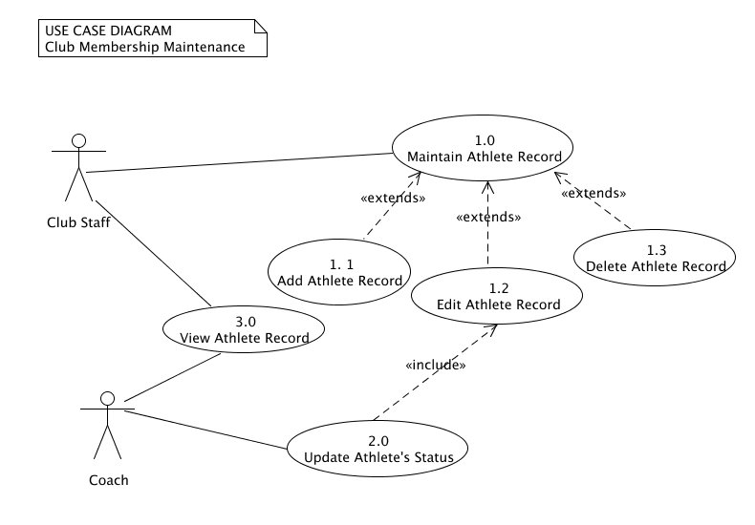

Place here the Use-Case Diagram. Make sure that the diagram is grouped as one and text does not wrap around the diagram.

*List of Actors:*

| Actors | Description |
| --- | --- |
| Club Staff | [Write the description of the actor. 3-5 sentences] |
| Coach | [Write the description of the actor. 3-5 sentences] |

*List of Use-cases:*

| Use-Case | Description |
| --- | --- |
| Use-Case 1.0 Maintain Athlete Record | [Write the description of the actor. 3-5 sentences] |
| Use-Case 1.1 Add Athlete Record | [Write the description of the actor. 3-5 sentences] |